FUNDAMENTALS OF C
C character set: every programming language comes with a particular characters set and c uses ascii charcter set, which is having 256 characters. In that we are having 52 alphabets [ a-z & A-Z ], 10 digits [ 0 to 9 ], 44 operators [ +, -, *,…], 14 separators [ , . “ “ ‘ ‘ { },…..] and remaining all are special characters.
Charcters | Ascii values
a-z | 97-122
A-Z | 65-90
0-9 | 48-57
Space | 32
* | 42
+ | 43
Tab key | 9
Back space | 8
Esc | 27

English Language | C Language
26 alphabet set | 256 ASCII character set
English words | Keywords - 32
English sentences | Instructions
English paragraphs | Programs

English documents | software

ASCII – American Standard Code for Information Interchange
IBM Corporation – International Business Machines – American Company
Java / .Net / Python – 65536 Unicode character set Universal Code
4 type of number formats
Binary format - %d
Decimal format - %d
Octal format - %o
Hexa decimal format - %x
Compilation & Execution process:
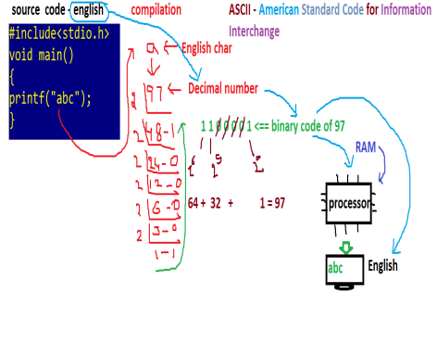
C TOKENS
The smallest individual words we are using in developing a C program are called tokens. They are of different types.
1. Keywords: The system predefined / reserved words are called keywords. Each keyword is having certain meaning and we can’t change this meaning. C comes with 32 keywords.
Eg: auto, break, continue, const, char, case, do, double, default, enum, else, extern, for, float, goto, int, long, while, switch, typedef, struct, union,….

